The Exiles – Game Research and Concept

# Introduction

For this research, I will be exploring platform games. I have chosen my 3 favourite games in this genre and 2 additional games with more unique concepts.

The chosen games are:

* Ori and the Blind Forest
* They Bleed Pixels
* Labyrneath
* Greedy Mimic
* The Woman Who Can’t Jump

# Game Mechanics and Features

*Take a look at some of the more interesting games you can think of and look into their unique mechanics and how they work with the game. Then consider how we can possibly use that or a variation of that in a game of our own.*

While there are common mechanics in the chosen games, they also have some unique ones.

## Ori and the Blind Forest – Moon Studios

Ori and the Blind Forest is known for its beautiful game world and heartfelt story. In terms of gameplay, the player has skills and abilities that they can upgrade as they progress in the game. By defeating enemies, the player can gain charge for placing soul links and points for their abilities.

**Main gameplay features:**

* Skill/ability trees with upgrades
* Checkpoints can be made with enough charge (soul link)
* 4 levels of difficulty

## They Bleed Pixels – Spooky Squid Games

They Bleed Pixels is a high difficulty action platformer inspired by H.P Lovecraft and classic horror. There is a heavy focus on combat (Store.steampowered.com, 2012). The combat system involves melee fighting with powerful combos that the player can unlock as they progress.

Aside from the high difficulty levels with deadly environments and enemies, the game also tells the story of the main character. Much like Ori and the Blind Forest, there is an emphasis on story and character development.

**Main gameplay features:**

* Melee fighting with combos
* Environment damages player and enemies (spikes, rotating saws, etc)
* Checkpoints that can be placed in levels after the player gains enough charge (similar to Ori and the Blind Forest)

## Labyrneath – 44Magdalene

Labyrneath is an indie game available on Kongregate. At first glance it looks like a simple platformer, but the art style and the music make the game very enjoyable and relaxing to play. A sequel to this game has recently been released.

Main gameplay features:

* “Wrap” mechanic (going to the edge of the level warps you to the other edge)
* Checkpoints throughout the levels. These can’t be placed manually.

## Greedy Mimic – eddynardo

In Greedy Mimic, the player is faced with several jumping puzzles to get to their objectives. The aim of the game is to “eat” NPCs to turn them into zombies. There are also enemies can be defeated by “stomping” on them. A level is only cleared when all NPCs have been eaten and all enemies defeated. The difficulty of each level increases significantly, with each level having a harder puzzle.

**Main gameplay features:**

* Player must “eat” NPCs to turn them into zombies
* Jumping height can be doubled by “stomping”
* Player can stomp on enemies to kill them
* All NPCs must be turned into zombies to complete the level – puzzle

## The Woman Who Can’t Jump – EPGstudios

As the name suggests, this is a platformer where the player cannot jump. Instead, the player can build pillars from under them. These pillars can also be moved. In order to complete levels, players must collect all coins in the level. This involves solving puzzles. Some levels may also have an optional “star” to collect, which is an optional puzzle.

**Main gameplay features:**

* No jumping – replaced with pillars made by the player
* Pillars can be moved
* Ability to undo moves and retry levels
* Puzzle – player must collect all coins in a level. Optional “star” rewards. Similar to Greedy Mimic.

# Game Design

*Look at examples of games you like the design of, or ones that you think are unique and reference them and use that to come up with some possible game ideas/designs.*

Ori and the Blind Forest and They Bleed Pixels are games with a heavy focus on story and narrative. On the other hand, Greedy Mimic and Woman Who Can’t Jump don’t present a story, but the focus of these games is providing challenges with their puzzles. Labyrneath sits somewhere in between, and while there might be a story associated with the main character, the developer does not put as much emphasis on storytelling.

As a player, I am always drawn to fascinating stories. I had the motivation to finish Ori and the Blind Forest because I kept being drawn to the story and wanted to know what happened next. Traditional platform games like Labyrneath are fun to play casually, but I never find the motivation to finish these games. Similarly, with puzzles I might play through some of the levels when looking for a difficult challenge, but I wouldn’t sink many hours into them without something else to motivate me.

Below is a summary of what I like/dislike about each game, as well as screenshots for design ideas.

## Ori and the Blind Forest – Moon Studios

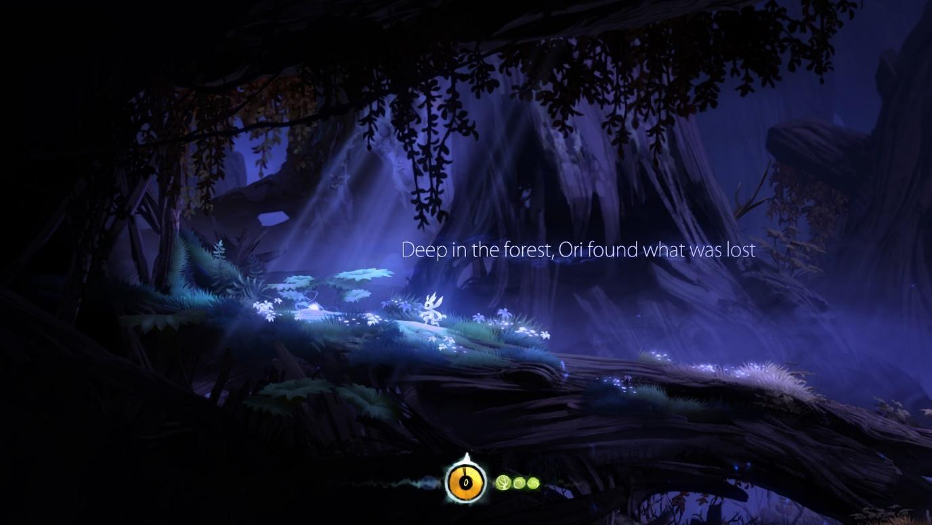

What I like about the design:

* Art style
* Atmosphere:
  + Lighting and particle effects to reflect the mood (e.g. in the prologue, when the forest dies the lighting and color change)
  + Music that fits the levels and story
* Parallax background environment
* Story/feelings/emotion
* Characters
* Scrolling text to narrate the story *(seen in screenshot), as well as voice-over narration*
* Pacing (can keep progressing to enjoy the story, even in higher difficulties)
* Combat abilities

## They Bleed Pixels – Spooky Squid Games

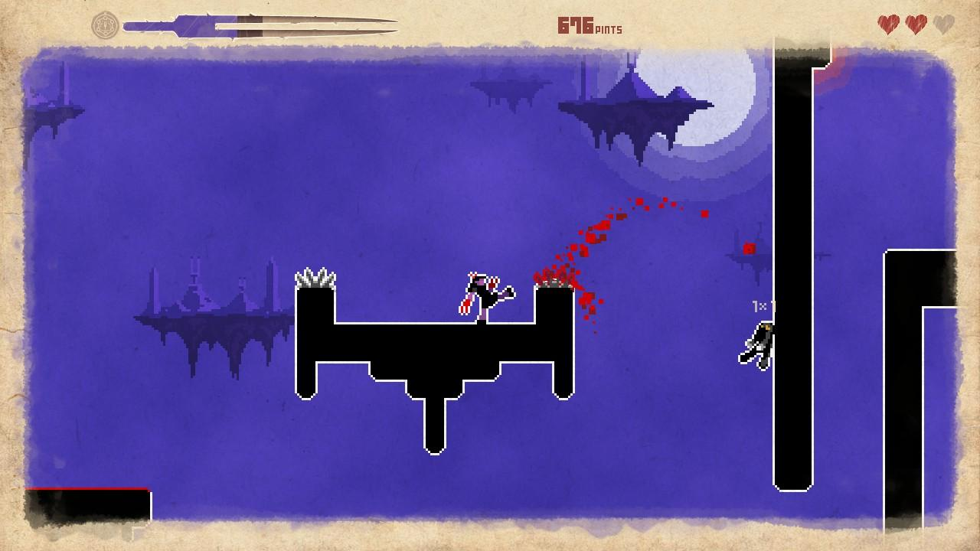

What I like about the design:

* Combat, fighting mechanics, combo
* Difficulty
* Map/level design, obstacles, enemies (using environment to kill enemies by kicking them to deadly traps, etc)
* Art style (pixel art)
* Main character

## Labyrneath – 44Magdalene

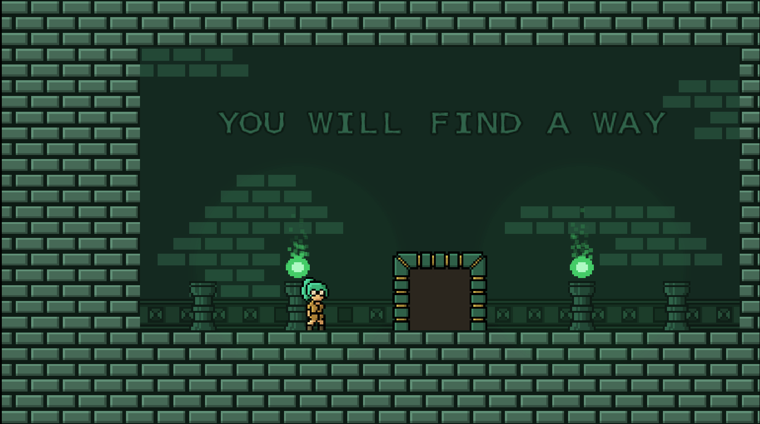

What I like about the design:

* Great music, each level song fits the level very well
* Nice atmosphere with the music and art (especially the animations and little details)
  + Makes the game look polished
* Character
* Art style (pixel art)
* Challenging levels

What I dislike about the design:

* Don’t like the color palette very much – seems very limited
  + At least it’s consistent
* “Jump” feels too high. Platforms are too high.
* Sound effect for jumping can get annoying

## Greedy Mimic – eddynardo

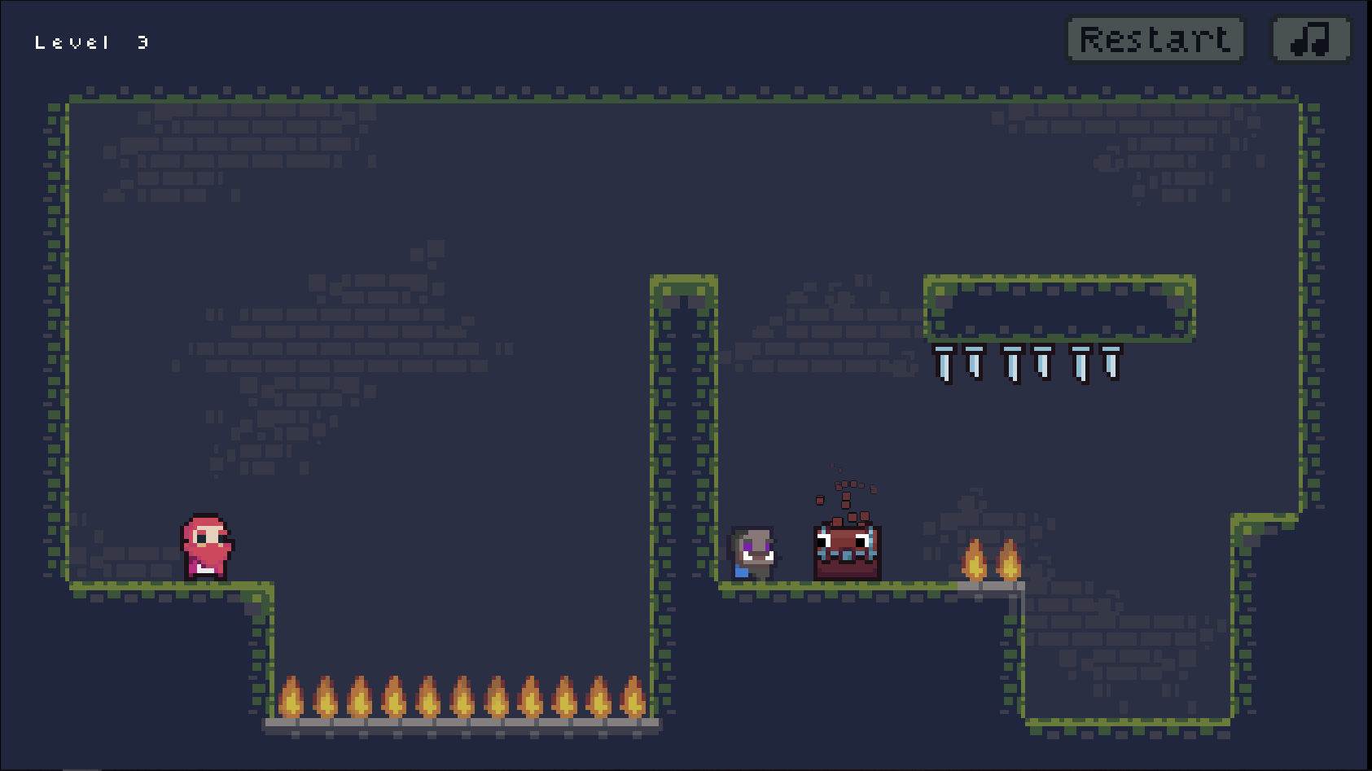

What I like about the design:

* Simple controls, simple mechanics
* Challenging puzzles from the beginning
* Difficulty increases at a reasonable pace

## The Woman Who Can’t Jump – EPGstudios

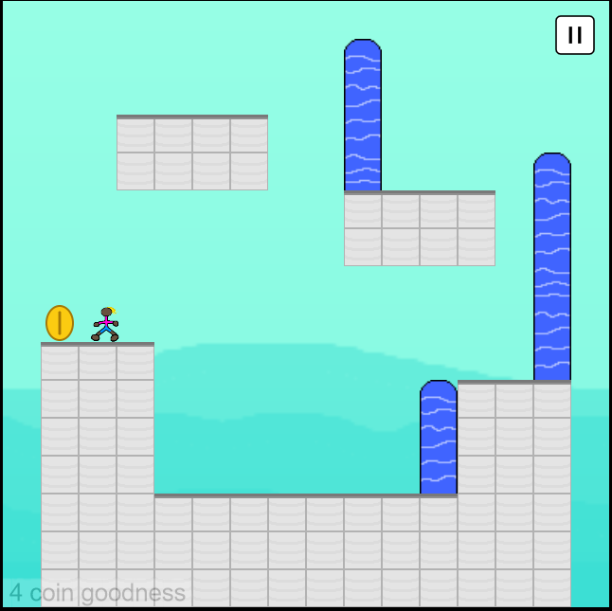

What I like about the design:

* One simple mechanic
* Challenging puzzles
* Difficulty increases each level
* Fast undo and retry after making/moving pillars, which leads to good flow

# Game Concept

*Based on the research made, come up with an idea and/or concept for a game.*

For our game, I’d like to explore the platformer sub-genre of action games. I would like the game to feature a simple combat mechanic with two or three abilities that can be picked up or unlocked during gameplay. This would keep the game very simple. To give players motivation to play through the game, we could invest on storytelling. This could be a short story narrated within 10 levels or less.

For the art style, pixel art is preferable, unless we’re drawing more inspiration from Ori and the Blind Forest. A platformer like Ori could take us longer to develop and polish, which presents a higher risk factor for the project.

Enemies and obstacles should be present throughout the levels. In addition to this, we can consider giving the players some puzzles during certain levels. However, we should decide whether we want to focus more on puzzle solving or storytelling.

The game should be polished with animations and details throughout the levels. For example, subtle particle effects around objects or enemies.

Summary of gameplay features and design:

* Preferably pixel art, unless drawing more inspiration from Ori
* Platformer like Ori and the Blind Forest
* Some sort of combat mechanic with 2 or 3 abilities that can be unlocked or picked up (must keep this simple)
* Obstacles and enemies
* Potentially some puzzles
* Either focus more on puzzle solving or storytelling. Can aim for a balance between the two?
* Polished game, with animations and particle effects. Can also consider sound effects and music.
* Checkpoints: need to decide if player can place these or if they will be pre-placed in the levels.
* Usage of text in the levels to give the player a tutorial and narrate the story

# References

Store.steampowered.com. (2016). *Ori and the Blind Forest: Definitive Edition on Steam*. [online] Available at: https://store.steampowered.com/app/387290/Ori_and_the_Blind_Forest_Definitive_Edition/ [Accessed 28 Sep. 2019].

Store.steampowered.com. (2012). *They Bleed Pixels on Steam*. [online] Available at: https://store.steampowered.com/app/211260/They_Bleed_Pixels/ [Accessed 28 Sep. 2019].